Policy Driven Energy Price Shocks and Macroeconomic Indicator

Energy prices, especially oil and natural gas, are highly sensitive to government actions, geopolitical decisions, and economic narratives, yet these drivers are often ignored by traditional forecasting models. This project estimates how policy driven events and economic news trigger sudden energy price movements and how these shocks transmit into broader macroeconomic outcomes.

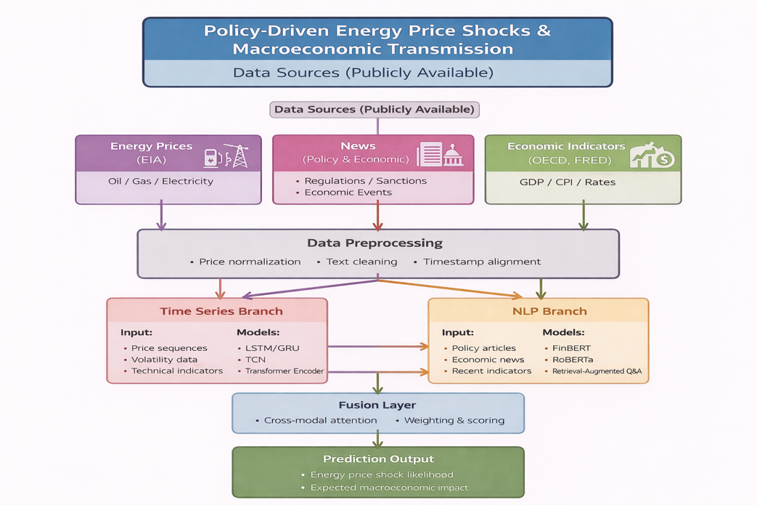

Data Acquisition :
Public data sources are used to capture energy market behavior, policy and economic news, and broader macroeconomic trends. Each data source is collected independently to allow flexible integration in the modeling pipeline.
Energy Price Data (EIA)
- Crude oil (WTI) and natural gas (Henry Hub) prices
- Publicly available and directly downloadable from the U.S. Energy Information Administration
News Articles Data
- Policy and economic news related to energy and macroeconomics
- Collected from GDELT and official government press releases
Macroeconomic Indicator Data (FRED)
- CPI, GDP, dollar rate, and related macro variables
- Retrieved from the Federal Reserve Economic Data (FRED) using an API key

